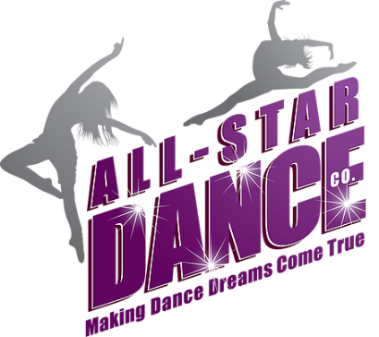

Welcome to ASDC After School

Laureate Park Elementary – Tuesdays 3:00-3:50pm
Sun Blaze Elementary – Tuesdays 3:00-3:50pm
Northlake Park Community School – Wednesdays 2:10-3:00pm
Eagle Creek Elementary – Thursdays 3:00-3:50pm
Moss Park Elementary – Fridays 3:00-3:50pm

All-Star Dance Company Studio Location
2479 N. Narcoossee Road
Saint Cloud, FL 34771
321-282-7016
Hours of Operation
Mon-Thurs 4:30-8:30pm
Saturdays 9:00-12:00pm
Dance Director
Courtney Englert
courtney@allstardancecompany.com
TUITION
Registration Fee | Due at time of registration | 25.00
Yearly Tuition $440.00 | Due Date | Amount
1st payment - | Time of registration | 55.00  *Amount will be prorated based on how many classes have been missed from the class start date. 30 total classes for the year, if registering online $55 will be paid but following month will be prorated. Prorated amount may be higher or lower than $55.00
2nd Payment - | October 1st | 55.00
3rd Payment - | November 1st | 55.00
4th Payment - | December 1st | 55.00
5th Payment - | January 1st | 55.00
6th Payment - | February 1st | 55.00
7th Payment - | March 1st | 55.00
8th Payment - | April 1st | 55.00

Tuition is due on the 1st of every month and can be paid by credit card or electronic check through the parent portal. If using a credit card there is a 2.9% processing fee added to the payment. There is no processing fee added to the electronic check. There is a $20 failed payment fee for returned electronic check payments.

PICK UP PROTOCOL
If someone else is going to be picking up your child you will need to give us their name prior to pick up so we can make sure a child is going home with the correct adult.
Each school has a different pick up location, they are:
Laureate Park Elementary – Car Loop
Sun Blaze Elementary – Bus Loop
Northlake Park Community School – School Lobby
Eagle Creek Elementary – Car Loop
Moss Park Elementary – Bus Loop

LATE PICK-UPS
Our instructors usually have a class immediately following the after-school classes so they need to leave the elementary schools on time. We have a 10 min grace period for those rare occasions where there is unexpected traffic. Habbitual late pick ups using the 10 min grace period will remove the grace period for the child. After the 10 minute grace period, a $1 per minute late pick up fee will be added to your dancer’s account. Please communicate with us immediately through our band app if you are going to be late to pick up. No communication from parents more than 30 minutes past our class end time will authorize us to call DCF for an abandoned child. Communication is the key!! Please see how to easily communicate with us through-out the season.

COMMUNICATION
We use the Band app to communicate with parents through out the season. This is a great app where we can share photos, videos, events on the calendar. You can also message me directly through the app. Think Facebook but it is a secret group that you have to have the code to join. First either download the app on your mobile device or go to this website https://band.us/ You’ll create a profile and then join the band group with this QR Code.
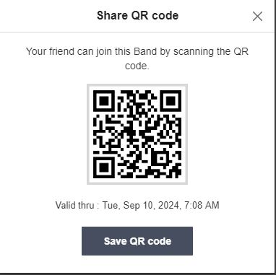

OPTIONAL PERFORMANCES
During the year we will have several performance opportunities for your dancer to participate in. You are not required to do all or really any of them. However, if you do choose to participate you will need to have our ASDC After School Uniform.

The Uniform Rental fee is $100. Since this is a rental that means the uniform will be returned to us after your last scheduled performance. Once it is returned to us in good usable condition (no stains, rips, discoloration, holes etc) we will refund you $50 of the $100 paid.

The uniform will look similar to this:
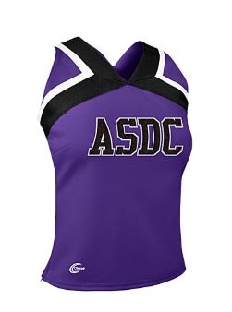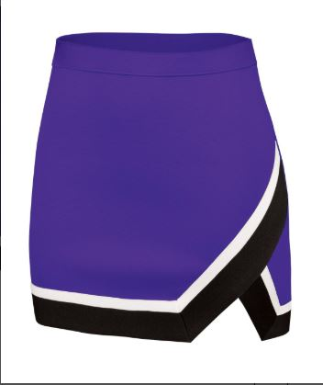

Each dancer will also need an accessory pack $45, this is theirs to keep and can be used year after year as we will be keeping this look for a while.

Accessory Pack includes the following:
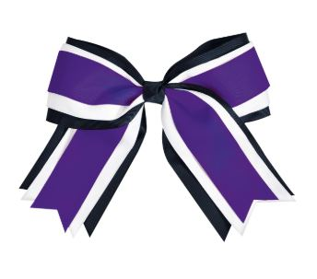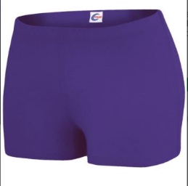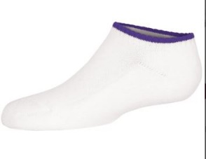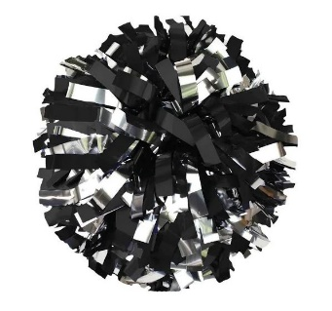
UNIFORM FITTING DAY
If you know your child will be participating in at least one of the performances listed below, they must be fitted for a uniform. Uniform rental fee must be paid 1 month prior to their first performance in order to make sure we have a uniform in their size available for them.
UNIFORM FITTING DAY – SEPTEMBER 21st 1:30-3:30pm at our studio location – 2479 N. Narcoossee Road, Saint Cloud, FL 34771
*Please have your dancer wear a leotard if they have one if not they will need to wear a bathing suit.

PERFORMANCES
Downtown Orlando Veteran’s Day Parade – November 9th
Saint Cloud Christmas Parade – December 7th
Orlando Solar Bears – Date - TBD –
*These are the 4 dates that we sent into the Orlando Solar Bears, they will let us know which one of the below dates they schedule us for.
December 6th
January 5th
March 20th
March 28th
Eagle Creek Elementary Carnival – February 28th
Sun Blaze Elementary Carnival – March 6th
Lake Nona YMCA Healthy Kids Day – Date TBD – Usually 3rd or 4th Saturday in April
Lake Nona High School Basketball Game – Date TBD
We will have more information on how to sign up for each individual performance.

